**Statistical Analysis Plan**

**DATA and STUDY DESIGNS**

Analyses were based on the cardiovascular disease research using linked bespoke studies and electronic health records (CALIBER) platform.1 CALIBER links individual electronic health records from consented general practices (Clinical Practice Research Datalink (CPRD)) with hospital care (Hospital Episodes Statistics (HES)) and death registry (Office of National Statistics).1 A description of the phenotyping and phenotype validations of CVD risk factors and endpoints have been published. 2 The use of CPRD and HES data for the research has been given by the CPRD Independent Scientific Advisory Committee (ISAC, protocol number 17_205). We conducted cohort analyses within the longitudinal CALIBER nationwide data to evaluate the association between angiotensin converting enzyme inhibitors (ACEI) and angiotensin II receptor blocker (ARB) prescriptions and influenza incidence.

**STUDY POPULATIONS**

We identified individuals aged 18 years or older registered in the current primary care practice for at least one year. The use of ACEI and ARBs were identified from CPRD prescription data using unique codes for medication (product code). The complete coding has been documented in public CALIBER code repository (Table 2).3 We defined ACEI users as individuals with any ACEI prescription. The date of study entry was defined as the *latest* date of the following: 1) the individual’s 18th birthday, 2) one year anniversary of GP registration, 3) January 1, 1998, or 4) among ACEI users, the first ACEI prescription date. We excluded individuals with a prior history of influenza and viral pneumonia before study entry. Follow-up is ceased at the *earliest* date of the following: 1) incident influenza, 2) death, 3) the end of registration with the practice; 4) the last date of the general practice data collection or 5) the end of the study period (May 31, 2016).

The exposure group is comprised of Individuals with a documented prescription of ACEI, and the comparison group of individuals without a prescription of ACEI, ARB or Aliskiren. The ACEI exposure, was defined as binary use and for sensitivity analyses as duration of ACEI use, defined as the sum of the ACEI prescription days, and classified into categories (none, <6 months use, 6 months-1.5 years, 1.5-2.5, 2.5-5, 5-7.5, 7.5-10 years and ≥ 10 years). Age at entry was obtained as the year of study entry date minus the birth year. Following the same methodology, to investigate the effect of ARB use on the risk of incident influenza, we constructed a longitudinal cohort comprised of individuals with ARB prescription and individuals without any use of ACEI, ARB and Aliskiren.

**OUTCOMES**

Individuals with a diagnosis of influenza were identified from primary and secondary care. Hospital Event Statistics (HES) using International Classification of Diseases (ICD), tenth revision [ICD-10]: J09-J11.8), CPRD using Read codes equivalent to ICD10 with the published coding conversion tool (<http://r-forge.r-project.org/R/?group_id=1598>) and reviewed subsequently for comparability (Table 1). We identified individuals whose first influenza diagnosis recorded as the primary cause of death within ONS using ICD10 and ICD9 equivalents (487, 488, 489). If the participant's first documentation of influenza appeared as the primary cause of death, it was regarded as an incident influenza.

**CLINICAL CHARACTERISTICS**

The body-mass index (BMI) at baseline was derived from the average weight and height measurements within a year before and a year after study entry. Obesity was defined as the presence of baseline BMI >= 30 kg/m2. We defined baseline smoking as ever and current smoking before and at study entry. We adjusted the fluctuation of flu season by incorporating dummy variables for year 1998-2000, 2009-2010 and 2011-2012. We adjusted 12 comorbidities associated with ACEI use and/or associated with influenza susceptibility as confounders in the association. These included hypertension, diabetes, asthma, angina, atherosclerotic heart disease (including unstable angina and acute myocardial infarction), atrial fibrillation, heart failure, stroke, cancer, chronic kidney disease, chronic obstructive pulmonary diseas and dementia. (Table 2) Individuals without a recorded diagnosis were assumed to be free from that condition. Diagnosis code lists for each condition were adapted from the CALIBER code repository (<https://caliberresearch.org/portal>).Influenza vaccination was identified from primary care data (table 3) and is included in the analysis.

**Management of missing values**

The frequency of missing values in study covariates was examined. In the current analyses we have one variable with missing values (BMI). We managed the missing values by deriving baseline obesity status based on BMI measures and consider individuals without a BMI ≥ 30 recorded as none-obese.

**Assessment of unmeasured confounding**

Sensitivity analyses were performed to assess the vulnerability of the study results to unmeasured confounding. This was done using E-value developed by Vanderweele et al.4 The maximum risk ratio of covariates and the outcome is obtained with the empirical estimates of the confounders in the model and the maximum risk ratio for unmeasured confounders estimated with available data.

**STATISTICAL ANALYSIS**

We constructed the study cohort following the aforementioned criteria (Figure). The adjusted covariates include age, sex, smoking, obesity, the above mentioned comorbidities and influenza vaccination. We then estimated hazard ratios associated with ACEI use compared to non-users for incident influenza, and subsequently by duration of ACEI use categories. The proportional hazards assumption is examined by Kaplan-Meir cumulative mortality curves. Sensitivity analyses were conducted to assess the impact of unmeasured confounding on the study results. The analyses of comparing ARB users and non-users was implemented independently with the same method.

We performed the analyses in the secured data safe haven environment, meeting the data safety and information government requirements by the UCL, NHS Digital and ONS. The statistical software used for data curation are Python, MySQL and R. Analyses were performed in SAS (version 9.4), R (version 3.6.1).

**Reference**

1. Denaxas SC, George J, Herrett E, Shah AD, Kalra D, Hingorani AD, et al. Data resource profile: cardiovascular disease research using linked bespoke studies and electronic health records (CALIBER). Int J Epidemiol. 2012;41(6):1625-38.
2. Denaxas S, Gonzalez-Izquierdo A, Direk K, et al. UK phenomics platform for developing and validating electronic health record phenotypes: CALIBER. J Am Med Inform Assoc 2019;26:1545-59.
3. CALIBER variable: [caliberresearch.org/portal/show/hypertension_and_heart_failure_gprdprod](https://caliberresearch.org/portal/show/hypertension_and_heart_failure_gprdprod), category (3), accessed at 15, March, 2020.
4. VanderWeele TJ, Ding P.Sensitivity Analysis in Observational Research: Introducing the E-Value. Ann Intern Med. 2017 Aug 15;167(4):268-274.

Table 1: definition of influenza

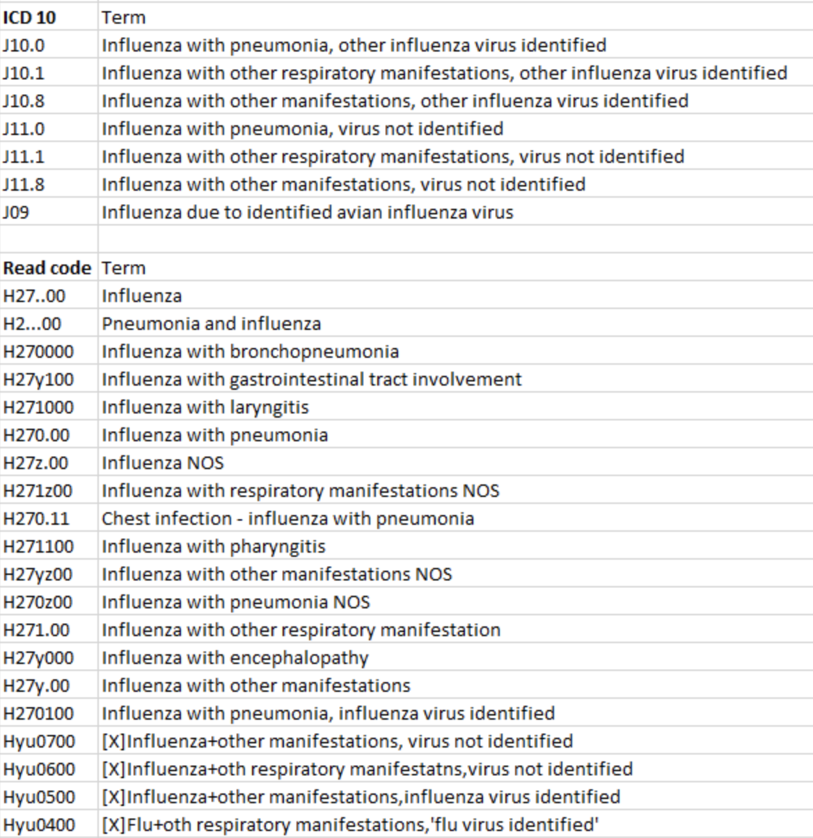

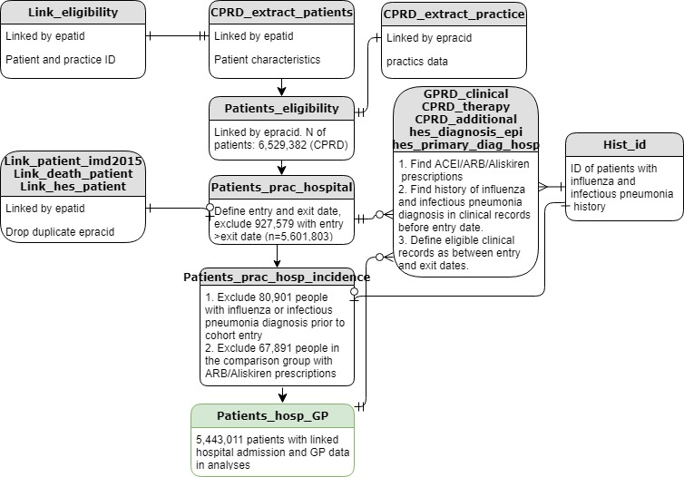

Figure: Entity Relational Diagram of the study population (ACEI analyses as an example).

*CPRD: Clinical Practice Research Datalink; ACEI: Angiotensin converting enzyme inhibitors; ARB: Angiotensin II Receptor Blockers; GP: general practise.

Table 2: definition of covariates

|  |  |  |
| --- | --- | --- |
| **Exposure and covariates** | **Definitions** | **Timing of measure** |
| Angiotensin-converting enzyme inhibitors | <https://caliberresearch.org/portal/show/hypertension_and_heart_failure_gprdprod>  (category 3) | Use before study exit |
| Angiotensin-II receptor antagonists | <https://caliberresearch.org/portal/show/hypertension_and_heart_failure_gprdprod>  (category 4) | Use before study exit |
| Age (years) | Age at study entry | At cohort entry |
| Sex | Male :1; Female:2 | - |
| Smoking status | <https://caliberresearch.org/portal/show/smoking_status_gprd> (categories 2,3,4)  ICD10: F17 | At any time before or at cohort entry |
| Diabetes | <https://www.caliberresearch.org/portal/show/dm_gprd> (categories 3,4,6)  <https://www.caliberresearch.org/portal/show/dm_hes> (categories 3,4,6) | At any time before or at cohort entry |
| Hypertension | <https://www.caliberresearch.org/portal/show/ht_gprd> (categories 3,4)  <https://www.caliberresearch.org/portal/show/ht_hes> (categories 3,4) | At any time before or at cohort entry |
| Stable angina | <https://www.caliberresearch.org/portal/show/sa_diagnosis_gprd> (category 4)  <https://www.caliberresearch.org/portal/show/angina_hes> | At any time before or at cohort entry |
| Unstable angina | <https://www.caliberresearch.org/portal/show/unangina_gprd> (category 3)  ICD10: I20.0, I24.0, I24.8, I24.9 | At any time before or at cohort entry |
| Myocardial infarction | <https://www.caliberresearch.org/portal/show/myo_infarct_gprd> (categories 3,4,5)  ICD10: I21 | At any time before or at cohort entry |
| stroke | <https://www.caliberresearch.org/portal/show/ischaemic_stroke_gprd>(category 3)  <https://www.caliberresearch.org/portal/show/haem_stroke_gprd> (categories 3-8)  <https://www.caliberresearch.org/portal/show/stroke_nos_gprd> (category 3)  ICD10: I60, I61, I63, I64, I62.0, I62.1, I62.9, G46.3, G46.4, G46.5, G46.6, G46.7, | At any time before or at cohort entry |
| atrial fibrillation | <https://www.caliberresearch.org/portal/show/af_gprd> (categories 3-6)  ICD10: I48 | At any time before or at cohort entry |
| heart failure | <https://www.caliberresearch.org/portal/show/hf_gprd> (categories 3,4,5,6)  https://www.caliberresearch.org/portal/show/hf_hes | At any time before or at cohort entry |
| Chronic obstructive pulmonary disease | <https://www.caliberresearch.org/portal/show/copd_gprd> (categories 3,5) <https://www.caliberresearch.org/portal/show/copd_hes> (categories 3,5) | At any time before or at cohort entry |
| chronic kidney disease | [https://www.caliberresearch.org/portal/show/renal_gprd (categories 3-7) https://www.caliberresearch.org/portal/show/renal_hes](https://www.caliberresearch.org/portal/show/renal_hes) (categories 3-7) | At any time before or at cohort entry |
| cancer | https://www.caliberresearch.org/portal/show/cancer_gprd  https://www.caliberresearch.org/portal/show/cancer_hes | At any time before or at cohort entry |
| dementia | <https://www.caliberresearch.org/portal/show/dementia_gprd> (categories 2-5) ICD10: F00, F01, F02, F03, F05.1, G30 | At any time before or at cohort entry |
| Asthma | ICD10 J45, J46 and corresponding Read code | At any time before or at cohort entry |
| Flu vaccination | As the following | At any time before exit or event |
| Seasonality | Three dummy variables for cohort entry year of 1998-2000, 2009-2010, 2011-2012 | At cohort entry |
| Body mass index | <https://www.caliberresearch.org/portal/show/bmi> | Derived from the average height and averaged weight between one year before and after cohort entry |
| Obesity | Derived from baseline BMI as the above and  ICD10: E66.0, E66.1, E66.2, E66.8, E66.9 hospital primary diagnosis before or at cohort entry |

Table 3: Read codes for influenza vaccination used in the analyses

|  |  |
| --- | --- |
| Code | term |
| 65E..00 | Influenza vaccination |
| 65E0.00 | First pandemic influenza vaccination |
| 65E1.00 | Second pandemic influenza vaccination |
| 65E2.00 | Influenza vaccination given by other healthcare provider |
| 9OX..11 | Flu vaccination administration |
| 9OX1.00 | Has 'flu vaccination at home |
| 9OX2.00 | Has'flu vaccination at surgery |
| 9OX3.00 | Has 'flu vaccination at hosp. |
| 9OX8.00 | Has influenza vaccination at work |
| F034G00 | Post influenza vaccination encephalitis |
| ZV04800 | [V]Influenza vaccination |
| ZV04811 | [V]Flu - influenza vaccination |
| 65ED.00 | Seasonal influenza vaccination |
| 65ED000 | Seasonal influenza vaccination given by pharmacist |
| 65EE000 | Administration of first intranasal influenza vaccination |
| 65EE100 | Administration of second intranasal influenza vaccination |
| 65EE.00 | Administration of intranasal influenza vaccination |
| 65ED200 | Seasonal influenza vaccination given while hospital inpt |
| 9N4q100 | DNA first intranasal seasonal influenza vaccination |